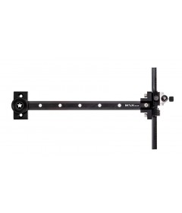

WNS SJA50 Sight

IN STOCK
Starting at:£25.78

- 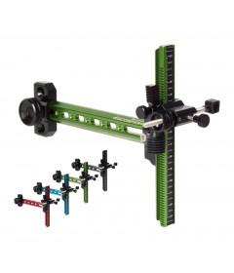

Krossen Scorpion Sight

IN STOCK
Starting at:£26.02

- 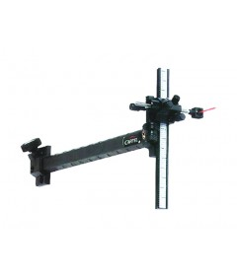

Cartel X-Pert Carbon Sight

IN STOCK
£31.30
- 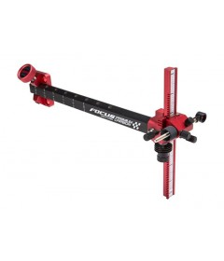

Cartel Focus Premium Carbon Recurve Sight

IN STOCK
Starting at:£36.95

- 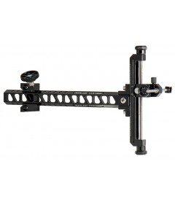

Avalon Tec One Recurve Target Sight

IN STOCK
Starting at:£58.01
14 Review(s)
- 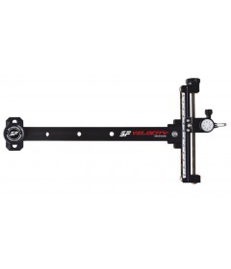

SF Velocity Carbon Recurve Sight

IN STOCK
Starting at:£58.45
- 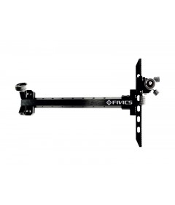

Soma Fivics FV-100 Recurve Target Sight

IN STOCK
Starting at:£60.00

- 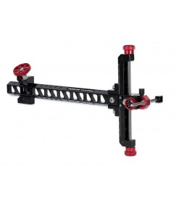

Avalon Tec One Recurve Target Sight - New Model

IN STOCK
Starting at:£62.20

- 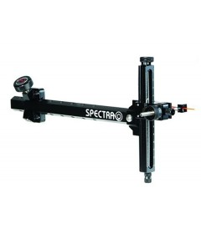

Cartel Spectra Carbon Sight - Black

IN STOCK
£102.31
£68.04

- 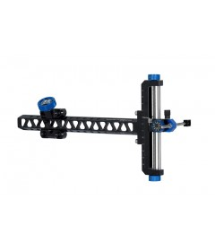

Avalon Tec X Recurve Sight

IN STOCK
Starting at:£75.34

- 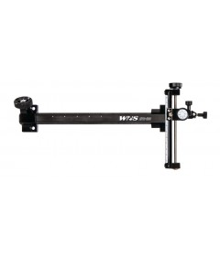

WNS SPR100 Carbon Recurve Sight

IN STOCK
Starting at:£79.00

- 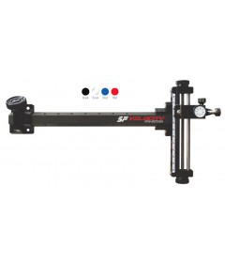

SF Velocity Carbon Pro Recurve Sight

IN STOCK
Starting at:£88.82
4 Review(s)
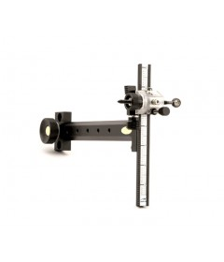

Shibuya Dual Click Standard Sight

IN STOCK
Starting at:£118.60

