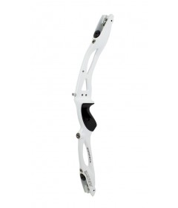

Samick Avante Recurve Riser 25" - Right Handed

IN STOCK
Starting at:£105.20

Kinetic Halo Recurv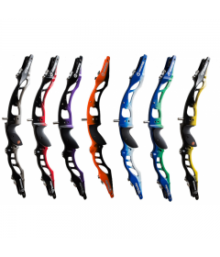e Risers

IN STOCK
Starting at:£111.18

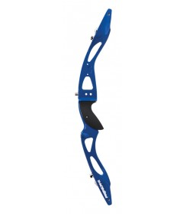

WNS Premium Recurve Riser

IN STOCK
Starting at:£125.82

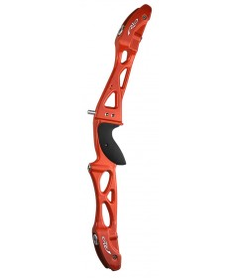

Rio Supercast Riser - 23"

IN STOCK
Starting at:£129.00

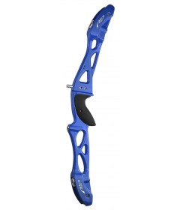

Rio Supercast Riser - 25"

IN STOCK
Starting at:£129.00

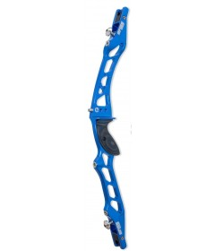

Kinetic Arios Recurve Riser - 25"

IN STOCK
Starting at:£133.93

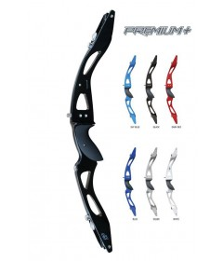

SF Premium Plus Recurve Riser

IN STOCK
Starting at:£137.76
SALE-17%

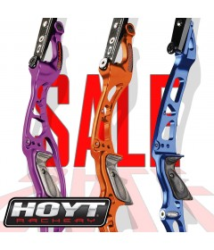

Recurve Riser Sale Items

IN STOCK
Starting at:£137.76
SALE-30%

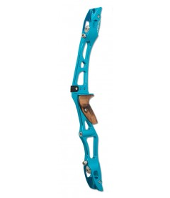

Kinetic Ember Recurve Riser - 23"

IN STOCK
Starting at:£159.85
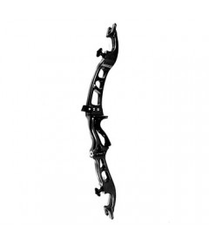

Hoyt Formula Excel Recurve Riser

IN STOCK
Starting at:£161.08
SALE-22%

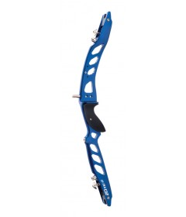

WNS Forged Elite 25" Recurve Riser

IN STOCK
Starting at:£196.58

- 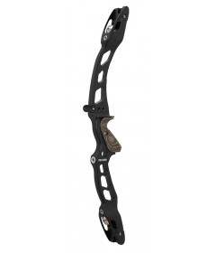

Kinetic Stylized Recurve Riser - 25"

IN STOCK
Starting at:£203.66
- 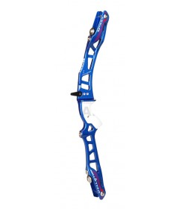

Fivics Vellator Recurve Riser - 25"

IN STOCK
Starting at:£223.80

- 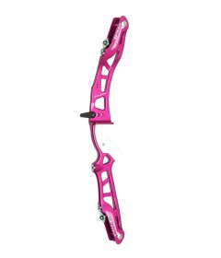

Fivics Vellator Recurve Riser - 23"

IN STOCK
Starting at:£223.80

- 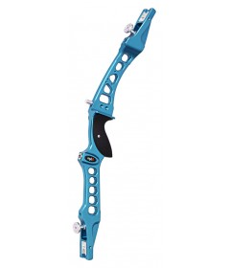

Mybo Wave 25" Recurve Riser

IN STOCK
Starting at:£225.00

- 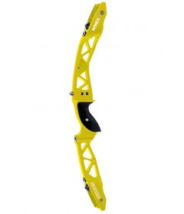

Win and Win Winex II Recurve Riser - 25"

IN STOCK
Starting at:£328.86

- 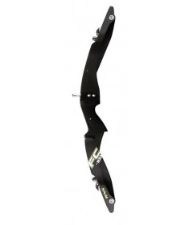

WNS FC-100 Recurve Riser

IN STOCK
Starting at:£359.53

- 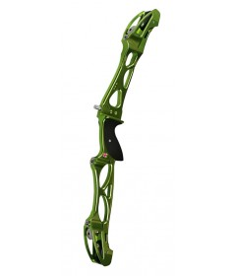

Mybo Elite 25" Recurve Riser

IN STOCK
Starting at:£360.00

