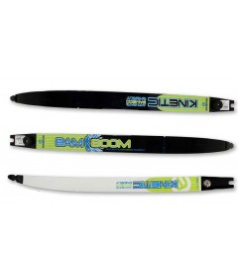

Kinetic Bamboom Recurve Limbs

IN STOCK
Starting at:£54.50

- 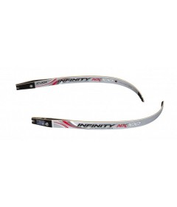

Cartel Midas Infinity NX100 Recurve Limbs

IN STOCK
Starting at:£61.69

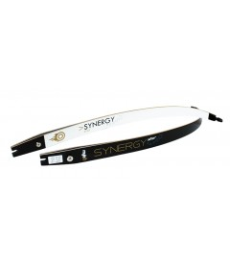

Mybo Synergy Star Recurve Limbs

IN STOCK
Starting at:£65.00

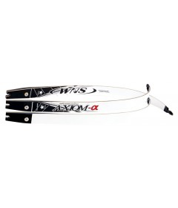

WNS Axiom Recurve Limbs

IN STOCK
Starting at:£65.16

- 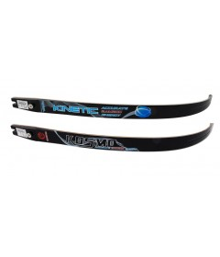

Kinetic Kosmo Recurve Limbs

IN STOCK
Starting at:£66.86

- 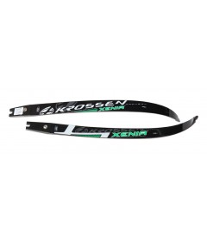

Krossen Xenia Recurve Limbs

IN STOCK
Starting at:£82.08

Recurve Limbs Sale Items

IN STOCK
Starting at:£97.20

- 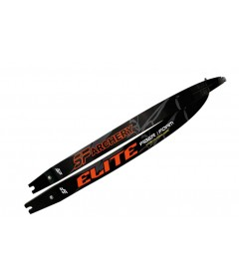

SF Elite Fibre Foam Recurve Limbs

IN STOCK
Starting at:£97.20

- 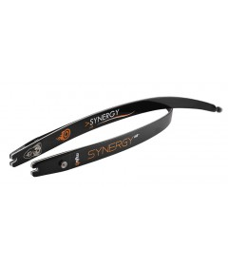

Mybo Synergy Air Recurve Limbs

IN STOCK
Starting at:£99.00

